Mobile Edge Computing

Sohaib Ahmed
21L-5635

Muhammad Hassan Khalid
21L-5692

Muhammad Hamza
21L-5636

INTRODUCTION
Mobile Edge Computing (MEC) has emerged as a pivotal paradigm in telecommunications, revolutionizing how computational resources are utilized at the network edge. This paper offers a comprehensive overview of MEC, focusing on its integration with existing and emerging technologies.
MEC brings computational capabilities closer to end-users, facilitating low-latency, high-bandwidth applications, and enabling new services like augmented reality and IoT. However, despite its promises, MEC faces several challenges that need addressing for its widespread adoption and optimization.
Key areas of focus include scalable system architectures, energy-efficient computing, robust security mechanisms, resource management, and the integration of advanced technologies for automated network management. By addressing these challenges, stakeholders can fully harness the potential of MEC, transforming network infrastructures and delivering enhanced user experiences.

RESEARCH METHODOLOGY
Edge Cloud Architecture:
The Three-Tier Edge-Cloud Orchestration Architecture is designed for mobile edge computing, efficiently distributing tasks across three layers: IoT Device, Edge Server, and Cloud. It ensures scalability and adaptability by dynamically allocating resources and distributing tasks based on urgency and workload. IoT devices decide whether to handle tasks locally or send them to edge servers. Edge servers handle urgent tasks, forwarding less urgent ones to the cloud if overloaded. The system optimizes resource allocation at the edge level to efficiently handle tasks from numerous devices, ensuring smooth operation and quick responses, particularly for urgent tasks.
Formulating the Offloading Problem:
The Delay-Aware Energy-Efficient (DAEE) [12] offloading algorithm is designed to save energy and meet task deadlines by using a virtual queue that mimics real tasks. This method minimizes long-term energy use by considering deadlines and network conditions. By creating a virtual queue through Lyapunov optimization, the algorithm can make smart offloading decisions in real-time without missing deadlines. It sets up a system model with actual and virtual queues to handle tasks efficiently. The system model is represented by the following equation for the distance between the  device and the
MEC server: where 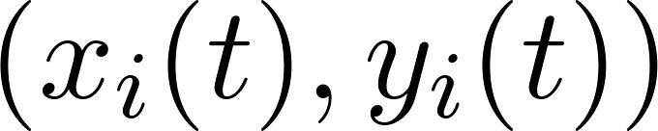 denotes the position of device i, and 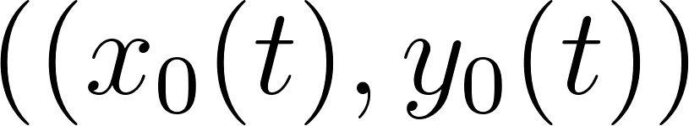 represents the MEC server's location.
Lyapunov-Guided Optimization:
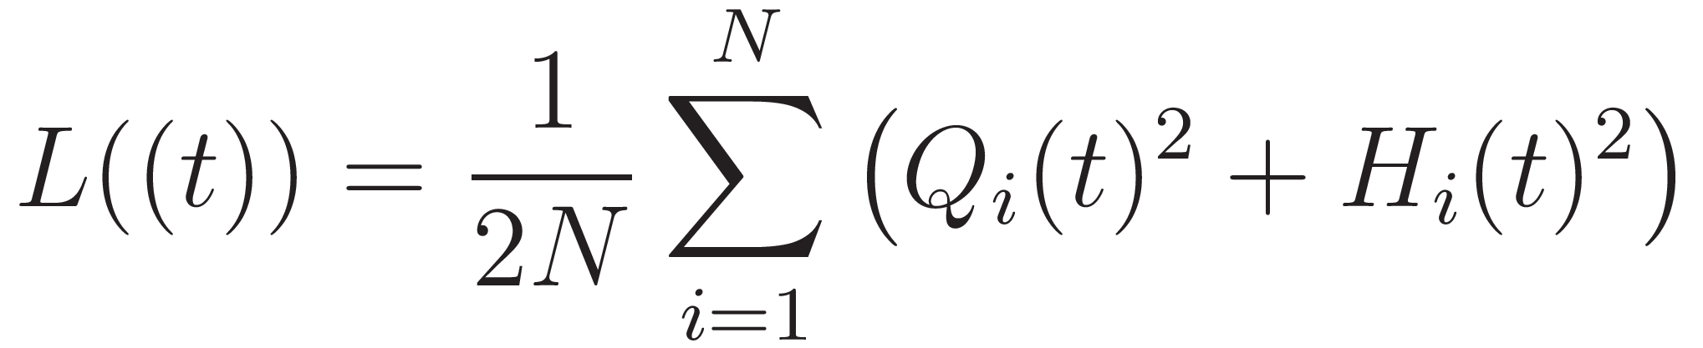
The DAEE [12] algorithm uses Lyapunov optimization to turn the offloading issue into a control problem for keeping the virtual queue stable. The Lyapunov function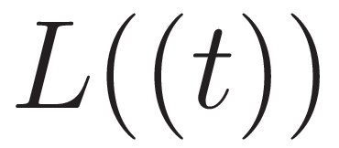, is crucial in this process as it shows the overall congestion in the system, with actual and virtual queue backlogs represented by specific variables  and 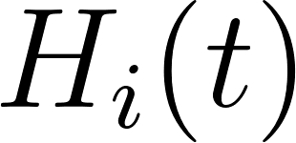 respectively.

The goal is to minimize a function to balance energy use and speed by making instant offloading choices based on current system status, without knowing future events.
Hierarchical Federated Learning
In Mobile Edge Computing (MEC), security is a big concern due to the distributed setup. To address this, robust security measures are needed to protect data privacy and integrity in a changing 5G environment. The challenge is to create a single security system that can defend against various cyber threats, which is a key area needing more research in MEC.
Hierarchical Federated Learning (HFL) is a model that can help fill this security gap. It works by improving security in a decentralized environment through a dual strategy.
- Local Computation: Defined by the equation This process enables individual edge devices to independently update their security parameters based on local data. This allows for the refinement of security measures at the device level, utilizing firsthand experiences with potential threats while maintaining the confidentiality of the data.
- Cluster Aggregation: This is encapsulated in the equation 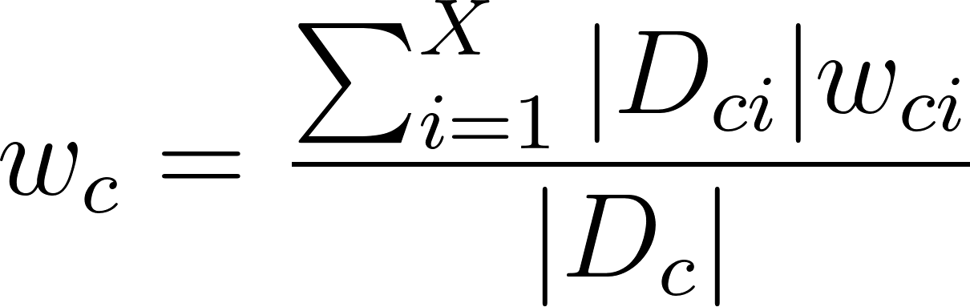, where the model updates at the cluster level are aggregated. It synthesizes the updates from individual devices to form a unified security model. By leveraging the collective learning from various devices, it enhances the overall security framework without compromising data privacy.
In a scenario where three devices choose a security protocol version based on their data, Device A switches from version 1 to 2 after analyzing 5 points of data. Device B always chooses version 3, and Device C prefers version 5 after processing 2 points of data. The decision on the best security protocol version is made by considering each device's choice in relation to the amount of data it has analyzed. The bar chart shows how individual preferences lead to a group decision on the preferred security protocol version for the network.
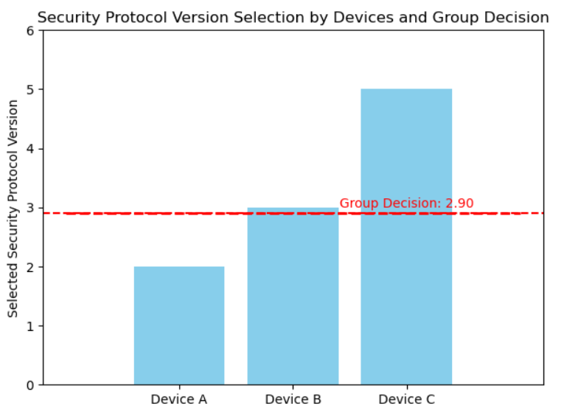
The HFL model combines local computation and cluster aggregation to create a strong security system for MEC. It offers a flexible and private way to secure decentralized MEC networks. This model adapts to new data and threats, ensuring a strong and adaptable security framework for future technologies. It not only addresses research gaps but also meets the crucial needs for securing MEC in the 5G era and beyond.
Integration of NFV and SDN
Network Function Virtualization (NFV) and Software-Defined Networking (SDN) are technologies that revolutionize resource management in Mobile Edge Computing (MEC). NFV separates network functions from specialized hardware, enabling them to operate as software on standard servers. This shift allows for agile deployment, scaling, and management of network services, transforming rigid networks into flexible environments. SDN centralizes control over network devices, separating control from data flow. This separation enables real-time traffic management and policy control through software, optimizing resource allocation based on network conditions and application needs. SDN ensures efficient bandwidth use, minimal latency, and adaptive network configurations without manual adjustments.
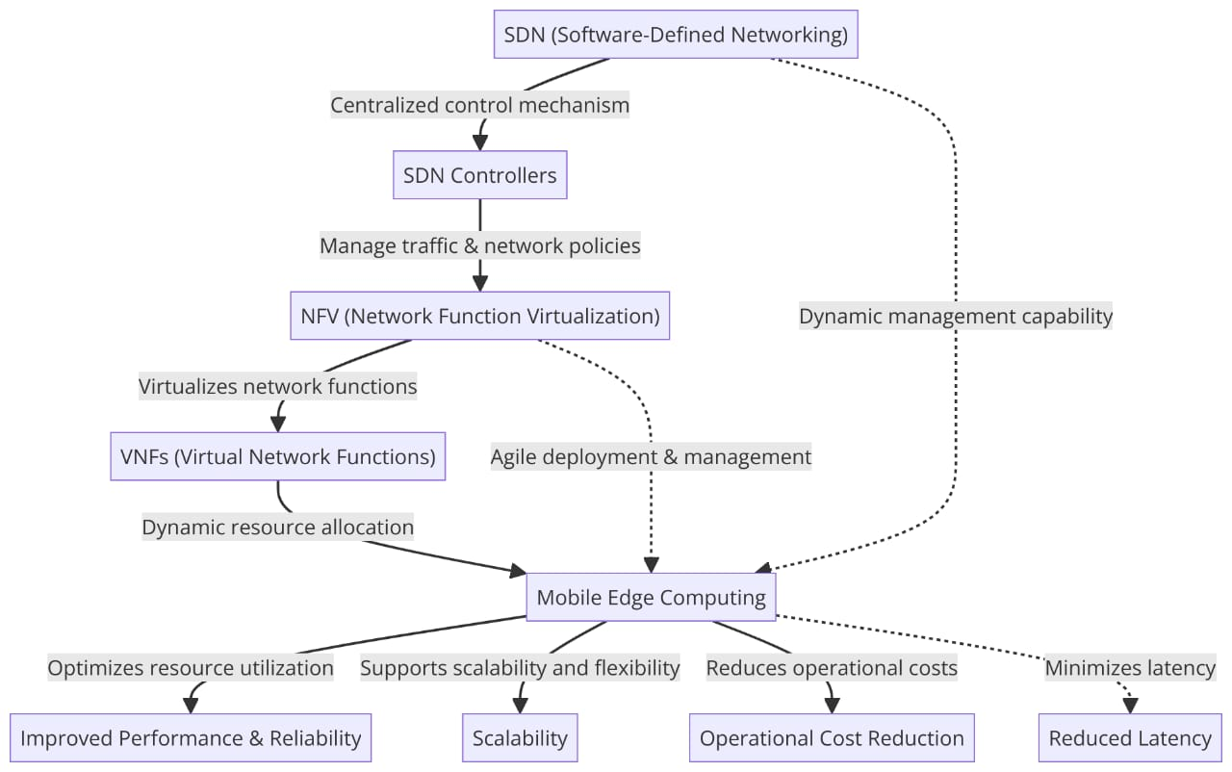

DL and ML for Automated Network Management:
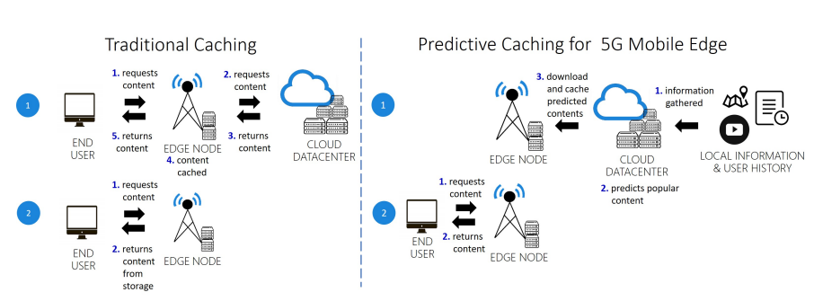
Figure. These two images show the difference between traditional caching and predictive caching using machine learning in mobile edge computing. Step 1 of predictive caching involves downloading popular content that matches a user's predicted preferences from the cloud to the edge node. In the second step, when the user asks for a specific content, there's a better chance that the content is already on the edge node, improving the user experience.

REFERENCES
[1] Y. Mao, C. You, J. Zhang, K. Huang, and K. B. Letaief, "A Survey on Mobile Edge Computing: The Communication Perspective," in IEEE Communications Surveys & Tutorials, vol. 19, no. 4, pp. 2322-2358, Fourthquarter 2017, doi: 10.1109/COMST.2017.2745201.
[2] X. Chen, L. Jiao, W. Li, and X. Fu, "Efficient Multi-User Computation Offloading for Mobile-Edge Cloud Computing," in IEEE/ACM Transactions on Networking, vol. 24, no. 5, pp. 2795-2808, October 2016, doi: 10.1109/TNET.2015.2487344.
[3] Y. Zhang, "Mobile Edge Computing for Beyond 5G/6G," in Mobile Edge Computing. Simula SpringerBriefs on Computing, vol 9. Springer, Cham, 2022, https://doi.org/10.1007/978-3-030-83944-4_4.
[4] Xiaojie Wang, Jiameng Li, Zhaolong Ning, Qingyang Song, Lei Guo, Song Guo, and Mohammad S. Obaidat, "Wireless Powered Mobile Edge Computing Networks: A Survey," ACM Comput. Surv. 55, 13s, Article 263 (December 2023), 37 pages, https://doi.org/10.1145/3579992.
[5] N. Abbas, Y. Zhang, A. Taherkordi, and T. Skeie, "Mobile Edge Computing: A Survey," in IEEE Internet of Things Journal, vol. 5, no. 1, pp. 450-465, Feb. 2018, doi: 10.1109/JIOT.2017.2750180.
[6] Mohammed Abd-Elnaby, Germien G. Sedhom, El-Sayed M. El-Rabaie, and Mohamed Elwekeil, "NOMA for 5G and beyond: literature review and novel trends," Wirel. Netw. 29, 4 (May 2023), 1629–1653, https://doi.org/10.1007/s11276-022-03175-7.
[7] A. Kaliwo, C. Nyirenda, "Enhancing Digital Health in 6G Networks: A Cybertwin-driven Fuzzy Approach to Medical Traffic Identification and Classification," by A. Kaliwo, C. Nyirenda, https://www.researchgate.net/publication/378534739.
[8] MABS Abir, MZ Chowdhury, "Digital Twin-based Aerial Mobile Edge Computing System for Next Generation 6G Networks," by MABS Abir, MZ Chowdhury, https://www.researchgate.net/figure/The-architecture-of-the-proposed-DT-based-aerial-MEC_fig1_378194844.
[9] W. Yu, TJ Chua, J. Zhao, "Orchestration of Emulator Assisted Mobile Edge Tuning for AI Foundation Models: A Multi-Agent Deep Reinforcement Learning Approach," by W. Yu, TJ Chua, J. Zhao, https://doi.org/10.48550/arXiv.2310.17492.
[10] S. Roy, S. Kalafatis, "RoboCon: A Modular Robotic Containerization, Orchestration, and Load Balancing Technique for Mixed Hierarchy Task Handling Across Computing Platforms," by S. Roy, S. Kalafatis, https://www.researchgate.net/publication/378617477.
[11] McClellan, M.; Cervelló-Pastor, C.; Sallent, S. Deep Learning at the Mobile Edge: Opportunities for 5G Networks. Appl. Sci. 2020, 10, 4735. https://doi.org/10.3390/app10144735
[12] X. He, Y. Chen and K. K. Chai, "Delay-Aware Energy Efficient Computation Offloading for Energy Harvesting Enabled Fog Radio Access Networks," 2018 IEEE 87th Vehicular Technology Conference (VTC Spring), Porto, Portugal, 2018, pp. 1-6, doi: 10.1109/VTCSpring.2018.8417646. keywords: {Gold;Delays;Task analysis;Computational modeling;Energy consumption;Cloud computing;Resource management},

